**Adventure Works Report**

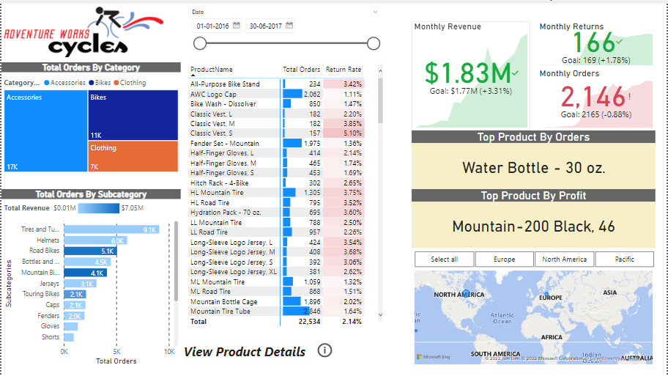

**Executive Summary Page**

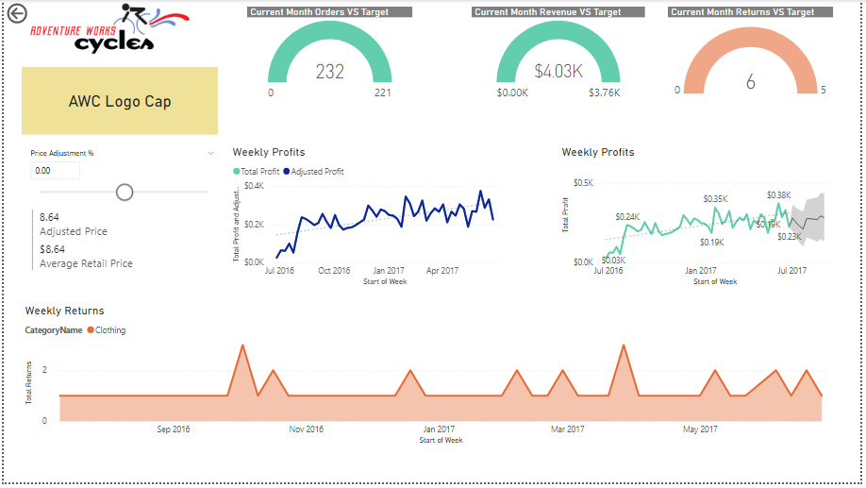

**Dynamic Products Page**

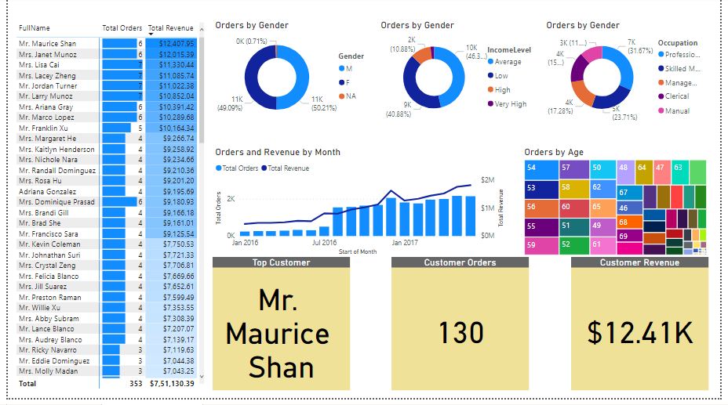

**Customer Analytics Page**